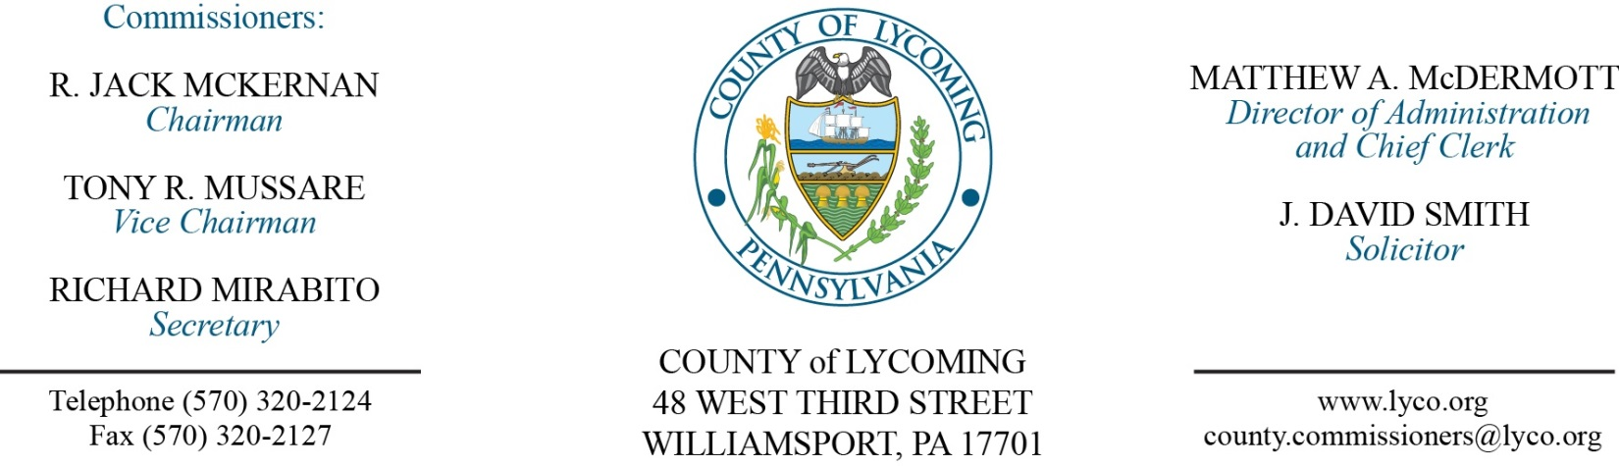
Commissioners’ Meeting Agenda
January 12, 2017

Opening Prayer

Pledge to the Flag

1.0 OPERATIONS

1.1 Convene Commissioners’ meeting.

1.2 Approve the minutes of the previous meetings.

1.3 Receive public comments (agenda items only).

2.0 ACTION ITEMS

2.1 Proclaim January as human trafficking awareness month. (Jim Sortman)

2.2 Award contract to XXXXXXXXXXXXX in the amount of $XXXXX for Flood Mitigation Acquisition Demolition.

2.3 Adopt resolution 2017-01 declaring property as surplus. (Jason Yorks)

2.4 Approve professional service agreement with Cleveland Brothers Equip Co., Inc. on an as needed basis. (Jason Yorks)

2.5 Approve professional service agreement with George A. Kint. (Jason Yorks)

2.6 Approve professional service agreement with Highway Equip & Supply Co., Inc. on an as needed basis. (Jason Yorks)

2.7 Approve professional service agreement with FLRI Detection, Inc. (Jason Yorks)

2.8 Award contract to Highway Equipment & Supply Company for 2017 Gradall XL 4100 6X4 Wheel Excavator with accessories and trade-in of 2007 Gradall XL 3300 Wheel Excavator for the total amount of $342,744.17. (Jason Yorks)

2.9 Approve professional service agreement with Ronald Travis, Esq for defending Jordan Rawls. (Adrianne Stahl)

2.10 Approve contract with SEDA COG for environmental review for FHR CDBG-DR. (Joshua Schnitzlein)

2.11 Approve the following contracts: (Mark Egly)
- Lycoming-Clinton Counties Commission for Community Action (STEP, Inc.) for the provision of Youth Workforce Development/Employment (YES) services for the period July 1, 2016 through June 30, 2017 not to exceed $65,000.
- Lycoming-Clinton Counties Commission for Community Action (STEP, Inc.) for the provision of Family Navigation services for the period July 1, 2016 through June 30, 2017 not to exceed $35,000.
- Catholic Social Services of the Diocese of Scranton d/b/a Big Brothers Big Sisters of the Bridge as the sponsoring organization for Lycoming County’s Big Brother Big Sister program for the period July 1, 2016 through June 30, 2017 not to exceed $30,000.
- Lycoming County Health Improvement Coalition for the provision of Strengthening Families Program services for the period July 1, 2016 through June 30, 2017 not to exceed $18,000.
- UMPC Susquehanna Health Home Care and Hospice for the provision of Nurse Family Partnership Program services for the period July 1, 2016 through June 30, 2017 not to exceed $75,000.
- Susquehanna Valley CASA – Voices for Children for the provision of child advocate services to dependent children for the period July 1, 2016 through June 30, 2017 not to exceed $30,000.

2.12 Approve update to TDA – RMS – remove Resource Recovery truck driver (drop off) effective 1/28/17 and PCD – remove temporary zoning subdivision officer effective 1/15/17.

2.13 Approve amendment to agreement with MCM Consulting Group, Inc for NG911 Phone Sys & ESInet. (John Yingling)

2.14 Approve 2017 Emergency Management Performance grant agreement from PEMA in the amount of $134,405.92. (John Yingling/Dan Dorman)

2.13 Approve the following personnel actions: (Roxanne Grieco)
Prison – Erin M. Dvorscak as full time replacement LPN – Pay grade 6 - $18.42/hour effective 1/23/17.
PCD – promotion of David L. Hubbard as full time replacement Zoning Administrator – Pay grade 8 - $38,444.32/annually effective 1/15/17.
PCD – Austin J. Daily as full time Zoning Officer – Pay grade 6 - $32,321.60/annually effective 1/15/17.
RMS – Resource Recovery – David E. Stine Jr. as full time replacement Shipping Clerk – Pay grade 6 - $21.39/hour effective 1/15/17.
District Attorney –NEU – full time replacement Assistant County Detective – union - $18.305/hour effective 1/17/17.

Recess Commissioners’ Meeting

3.0 SALARY BOARD

3.1 Convene Salary Board.

3.2 Approve update to salary schedule.

3.3 Adjourn Salary Board.

4.0 BOARD of ASSESSMENT REVISION

4.1 Convene Board of Assessment Revision.

4.2 Approve the following real estate refunds:
50-001-104.A - Craig Colocino - $310.70
66-009-215 - Craig & Martha Harris - $161.25
71-005-300 - David R Webb Co Inc - $1234.55
26-331-204 - Andrew & Jolene Marshall - $34.64
43-014-180 – Hillview Baptist Church - $2186.99

4.3 Approve the following real estate exonerations:
66-009-215 L Craig & Martha Harris 1228 Anne St $ 64,000 $ 20,310.
72-002-301 Amoma LLC 421 High St $859,450 $191,770.
72-002-316 Amoma LLC 400 Park Ave $802,820 $172,750.

4.4 Adjourn Board of Assessment Revision.

Reconvene Commissioners’ Meeting

5.0 REPORTS/INFORMATION ITEMS

5.1 Lycoming County transferred $50,000 to White Deer Golf Course per contractual obligation. (Beth Johnston)

5.2 Present 10 year service pins:
Craig Konkle DPS.
Diana Cleveland IS.

5.3 Present Retirement Clock to R. Kevin Stroble. (Kevin DeParlos)

6.0 COMMISSIONER COMMENT:

7.0 PUBLIC COMMENT:

8.0 NEXT REGULARLY SCHEDULED MEETING: Planning Session on Tuesday, January 17, 2017.

9.0 ADJOURN COMMISSIONERS’ MEETING.

