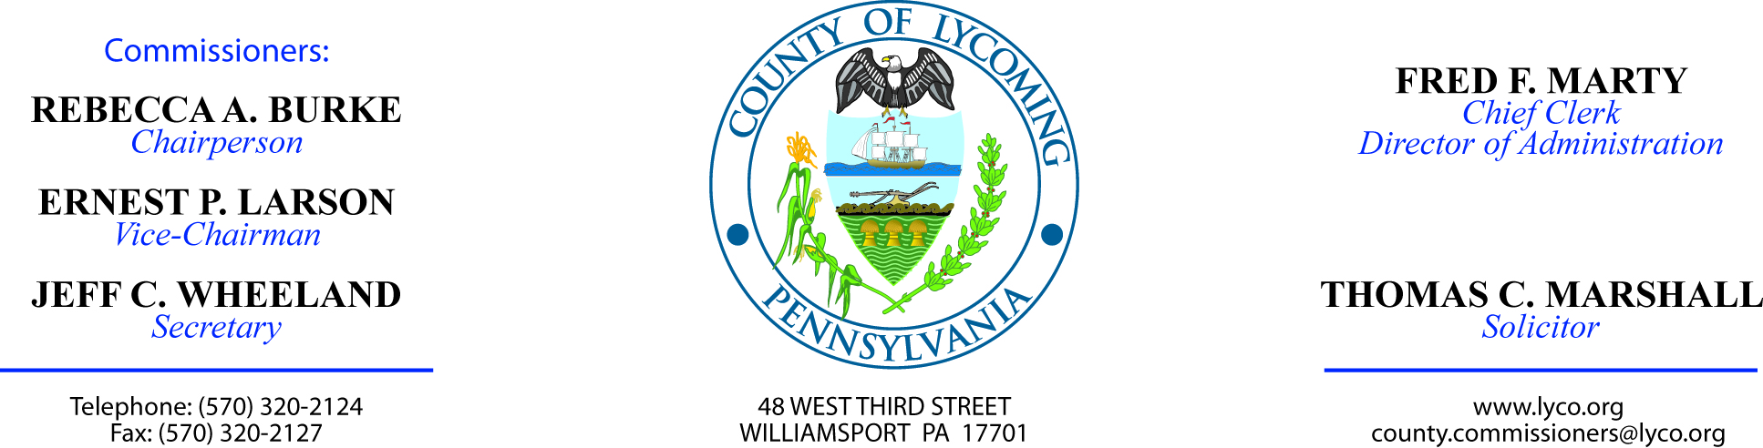

Minutes of the Meeting of
September 24, 2009

Commissioner Burke - Absent
Commissioner Larson - Present
Commissioner Wheeland - Present

Assistant Solicitor Read - Present

1.0 OPERATIONS

1.1 CONVENE COMMISSIONERS MEETING. Mr. Wheeland convened the Commissioners Meeting 10:02 a.m.

1.2 Approve the minutes of the previous meetings. A motion by Mr. Larson and seconded by Mr. Wheeland and passed (2-0), approved the minutes of the previous meeting as they are recorded.

1.3 Receive Public Comments (Agenda Items Only). Mr. Wheeland opened the floor to public comment on agenda items only, and none were received.

2.0 ACTION ITEMS

2.1 approve amendment #2 with analytical laboratory services. A motion by Mr. Larson and seconded by Mr. Wheeland and passed (2-0), approved amendment #2 to contract with Analytical Laboratory Services, Inc.

2.2 award contract to nestlerode contracting company. A motion by Mr. Larson and seconded by Mr. Wheeland and passed (2-0), awarded contract to Nestlerode Contracting Company in the amount of $1,206,422.94 for replacement of County bridge 110 subject to review and approval by solicitor.

2.3 APPROVE renewal of adobe products. A motion by Mr. Larson and seconded by Mr. Wheeland and passed (2-0), approved one year licensing renewal of Adobe products from CDW-G in the amount of $1,318.44.

2.4 approve invoice from sungard. A motion by Mr. Larson and seconded by Mr. Wheeland and passed (2-0), approved invoice in the amount of $1,218 from SunGard for Cognos Reporting licenses from September through December 2009.

2.5 APPROVE psa with robert meachum. A motion by Mr. Larson and seconded by Mr. Wheeland and passed (2-0), approved professional service agreement with Robert Meachum for JPO.

2.6 APPROVE HMRF grant receipt. A motion by Mr. Larson and seconded by Mr. Wheeland and passed (2-0), approved Hazardous Materials Response Fund grant receipt from PEMA in the amount of $19,183.

2.7 approve agreement with county of colombia. A motion by Mr. Larson and seconded by Mr. Wheeland and passed (2-0), approved agreement with County of Columbia for reimbursing 911 fees in the amount of $16,155.75 for years 2007, 2008 and the first half of 2009.

2.8 Authorize connie turner to sign on behalf of county. A motion by Mr. Larson and seconded by Mr. Wheeland and passed (2-0), authorized Connie Turner to sign as County representative on Pennsylvania State Police CLEAN terminal agreements.

2.9 approve amendment to agreement with laran bronze. A motion by Mr. Larson and seconded by Mr. Wheeland and passed (2-0), approved amendment to agreement with Laran Bronze regarding woodhick sculpture establishing installation deadline as December 2, 2009.

2.10 Award contract to feesers. A motion by Mr. Larson and seconded by Mr. Wheeland and passed (2-0), awarded contract for food products to Feeser’s Inc. on a per item basis.

2.11 Award contract to keyco. A motion by Mr. Larson and seconded by Mr. Wheeland and passed (2-0), awarded contract for food products to Keyco on a per item basis.

2.12 APPROVE sub contract with step, inc. A motion by Mr. Larson and seconded by Mr. Wheeland and passed (2-0), approved subrecipient monitoring contract with STEP, Inc. for MATP in the amount of $116,479.

2.13 APPROVE emergency shelter grant receipt. A motion by Mr. Larson and seconded by Mr. Wheeland and passed (2-0), approved Emergency Shelter grant receipt from DCED in the amount of $59,004.

2.14 APPROVE county policy 1304. A motion by Mr. Larson and seconded by Mr. Wheeland and passed (2-0), approved County policy 1304 - Professional Services: Independent Contractor vs. Employee Classification - of the Lycoming County Policy & Procedures Manual.

2.15 APPROVE bill of sale. A motion by Mr. Larson and seconded by Mr. Wheeland and passed (2-0), approved Approve bill of sale for 2003 Ford Expedition in the amount of $6,582.

2.16 APPROVE bill of sale. A motion by Mr. Larson and seconded by Mr. Wheeland and passed (2-0), approved bill of sale for 2002 Ford Explorer in the amount of $3,425.

Mr. Wheeland recessed the Commissioners’ Meeting at 10:11 a.m.

3.0 SALARY BOARD

3.1 CONVENE SALARY BOARD. Controller Rogers was present.

3.2 Rms - A motion by Mrs. Rogers and seconded by Mr. Larson and passed (3-0), approved the reclassification of Joseph H. Bryson as full time Equipment Operator – Pay grade 6 - $14.85/hour effective 10/04/09.

3.3 ADJOURN SALARY BOARD. A motion by Mrs. Rogers and seconded by Mr. Larson and passed (3-0), adjourned the Salary Board at 10:12 a.m.

4.0 BOARD OF ASSESSMENT APPEALS

4.1 CONVENE BOARD OF ASSESSMENT APPEALS. Mr. Wheeland convened the Board of Assessment Appeals at 10:12 a.m.

4.2 APPROVE change of value notices. A motion by Mr. Larson and seconded by Mr. Wheeland and passed (2-0), approved the 4,791 real estate change of value notices as a result of Clean & Green.

4.3 adjourn BOARD OF ASSESSMENT APPEALS. A motion by Mr. Larson and seconded by Mr. Wheeland and passed (2-0), adjourned the Board of Assessment Appeals at 10:13 a.m.

Mr. Wheeland reconvened the Commissioners’ Meeting at 10:13 a.m.

5.0 REPORTS / INFORMATION ITEMS.

5.1 Mark Davidson of the Conservation District, introduced his new employee, Eric Beaver.

6.0 PUBLIC COMMENT. Mr. Wheeland opened the floor to public comment none were received.

7.0 NEXT REGULARLY SCHEDULED MEETING. Mr. Wheeland announced the next regularly scheduled meeting as a work session on Tuesday, September 30, 2009.

8.0 ADJOURN COMMISSIONERS’ MEETING. A motion by Mr. Larson and seconded by Mr. Wheeland and passed (2-0), adjourned the Commissioners’ Meeting at 10:15 a.m.

